CREATIVE EDUCATIONAL SERVICES
END OF TERM I EXAMINATIONS
2024

ENGLISH

NAME: ____________________________________________ Middle CLASS

1. Name these objects.
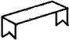 _______________ 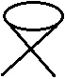 _______________ 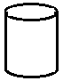 _______________

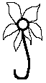 _______________ 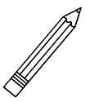______________ 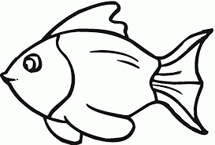____________
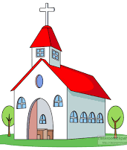 _____________ 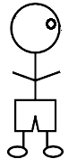______________ 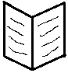____________
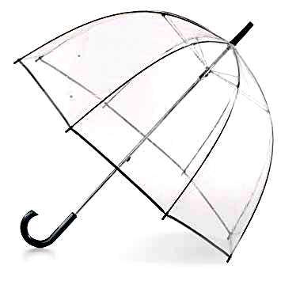_______________ ______________ ____________

2. Make five sentences with the word in the table.
This | book  pencil  ruler  pen  box | belong to | us
__________________________________________________________________
__________________________________________________________________
__________________________________________________________________
__________________________________________________________________
__________________________________________________________________

3. Use has or have to complete sentences.
She _____________ a red dress.
We _____________ a white car.
He _____________ a big house.
It ______________ one eye.
They ___________ a nice house.

4. Use a or an.
My mother has ______ knife.
Give me _______ apple.
She has _______ orange.
It is _______ red flower.
She is __________ teacher.
We have ________ good phone.
It is ___________ aeroplane.
5. Make sentences from these pictures.
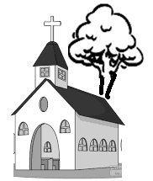 __________________________________________________
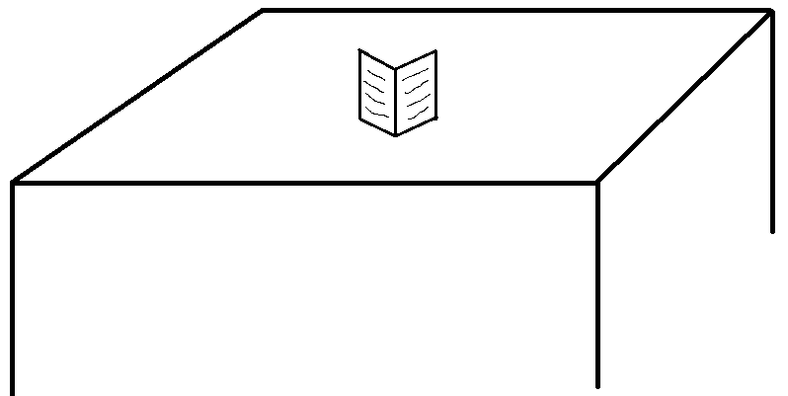 __________________________________________________
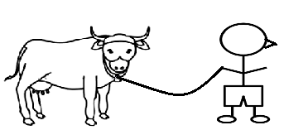 __________________________________________________
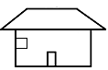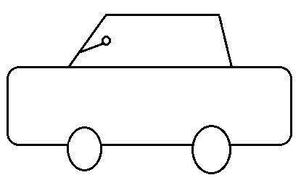 __________________________________________________
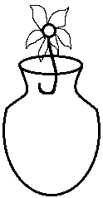 __________________________________________________
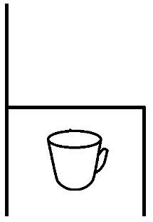 __________________________________________________

6. Write yes or no.
Is this a tree?
____________________________________________________________
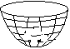Is this a box?
____________________________________________________________
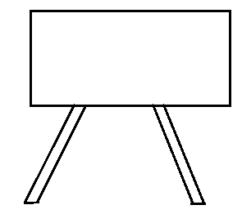Is this a blackboard.
____________________________________________________________
Is this a star?
____________________________________________________________
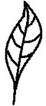Is this a leaf?
____________________________________________________________
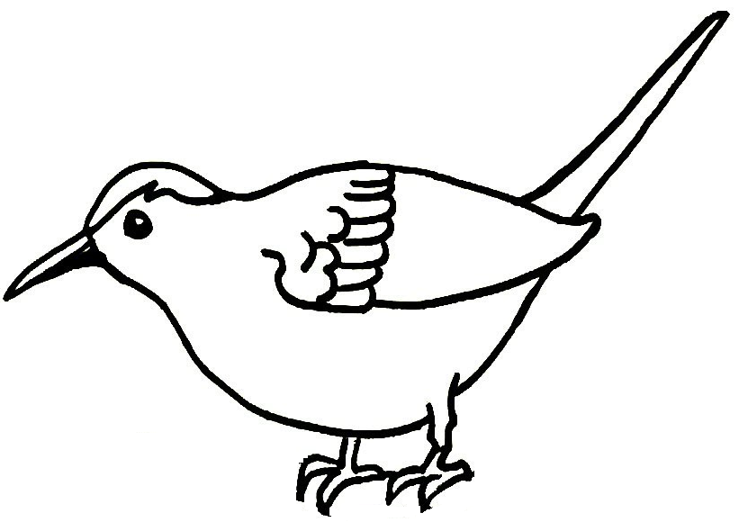Is this a kite?
____________________________________________________________
Is this a stone?
____________________________________________________________

7. Fill in the correct word: under, behind, near,on, over, in.
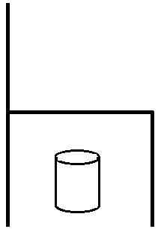 The tin is ____________________ the chair.
The book is ________________ the pencil.
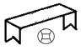 The ball is ___________________ the bench.
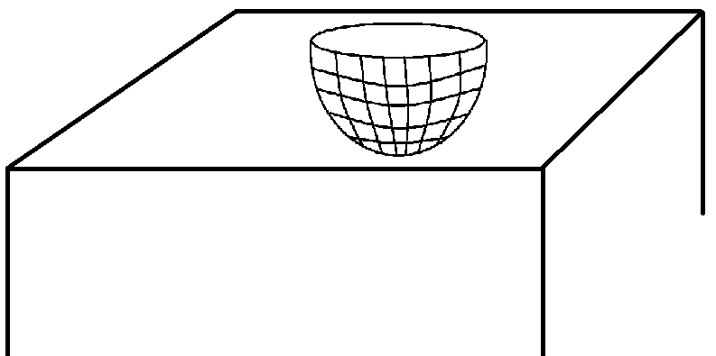 The basket is ___________________ the table.
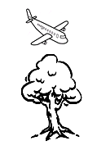 The aeroplane is flying ____________ the tree.
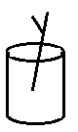 The stick is ___________ the tin.
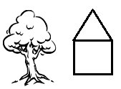 The tree is ______________ the hut.

End
Good luck

